Class Activity: D
1.Names of students above the class average (use reduce for the average, then filter + map)
CODE:

const students = [
{ name: "Ali", score: 92, active: true },
{ name: "Sara", score: 78, active: true },
{ name: "Bilal", score: 45, active: false }
];

const averageScore = students.reduce( (sum, s) => sum + s.score, 0) / students.length;
const topStudents = students
.filter(s => s.score > averageScore)
.map(s => s.name);

console.log(topStudents); // Output: ["Ali", "Sara"]

OUTPUT:
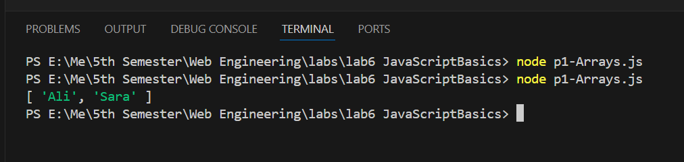

2. students.some(s => s.score > 90) and students.every(s => s.score > 40) — log both
CODE:

const students = [
{ name: "Ali", score: 92, active: true },
{ name: "Sara", score: 78, active: true },
{ name: "Bilal", score: 45, active: false }
];

// students.some(s => s.score > 90) and students.every(s => s.score > 40) — log both
console.log("Some students scored above 90:", students.some(s => s.score > 90)); // Output: true
console.log("All students scored above 40:", students.every(s => s.score > 40));
// both conditions combined
console.log("Some students scored above 90 and all students scored above 40:", students.some(s => s.score > 90) && students.every(s => s.score > 40));

OUTPUT:
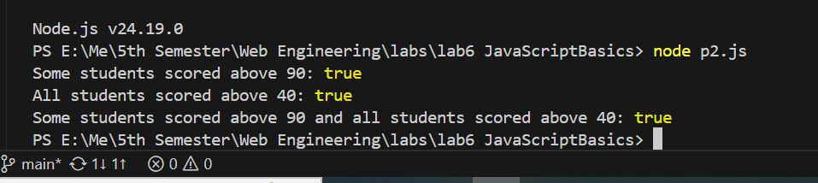

3. Sort a copy high→low by score — do not mutate the original ([...students].sort(...))
CODE:

const students = [
{ name: "Ali", score: 92, active: true },
{ name: "Sara", score: 78, active: true },
{ name: "Bilal", score: 45, active: false }
];

// Sort a copy high→low by score — do not mutate the original ([...students].sort(...))

const highLowByScore = [...students].sort( (a, b) => b.score - a.score);

console.log("Students sorted high→low by score:", highLowByScore);

OUTPUT:
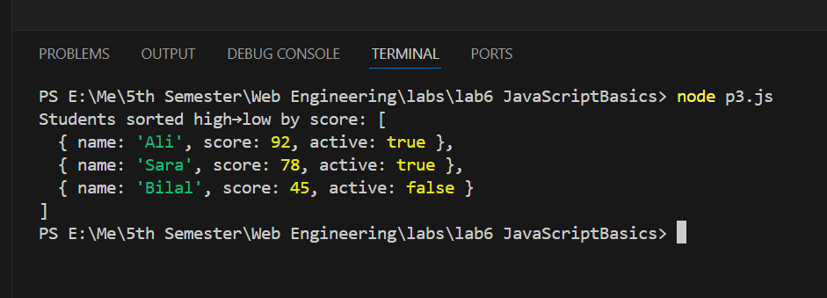

Class Activity: E products + groupBy
1.inStock titles via filter + map
CODE:

const products = [
{ id: 1, title: "Keyboard", price: 4500, category: "peripherals", inStock: true },
{ id: 2, title: "Mouse", price: 1800, category: "peripherals", inStock: false },
{ id: 3, title: "USB Hub", price: 1200, category: "cables", inStock: true },
];

// inStock titles via filter + map

const inStockTitles = products
.filter(p => p.inStock)
.map(p => p.title);

console.log("In-stock product titles:", inStockTitles); // Output: ["Keyboard", "USB Hub"]

OUTPUT:
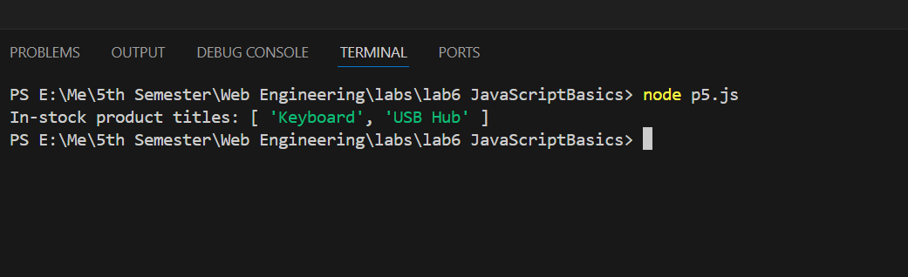

2. Total price via reduce
CODE:

const products = [
{ id: 1, title: "Keyboard", price: 4500, category: "peripherals", inStock: true },
{ id: 2, title: "Mouse", price: 1800, category: "peripherals", inStock: false },
{ id: 3, title: "USB Hub", price: 1200, category: "cables", inStock: true },
];

const total = products.reduce( (sum, p) => sum + p.price, 0);
console.log("Total product value:", total);

OUTPUT:
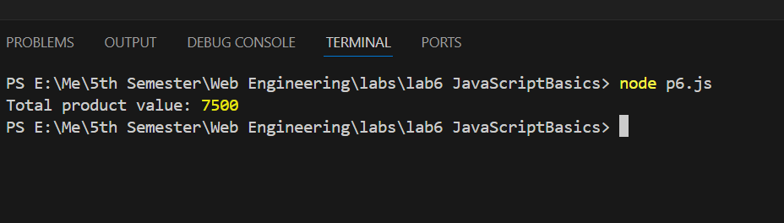

3.groupBy(products, "category") with reduce → { peripherals: [...], cables: [...] }
CODE:

const products = [
{ id: 1, title: "Keyboard", price: 4500, category: "peripherals", inStock: true },
{ id: 2, title: "Mouse", price: 1800, category: "peripherals", inStock: false },
{ id: 3, title: "USB Hub", price: 1200, category: "cables", inStock: true },
];

// groupBy(products, "category") with reduce → { peripherals: [...], cables: [...] }
const groupByCat = products.reduce( (acc, p) => {
const groupKey = p["category"];
if (!acc[groupKey]) {
acc[groupKey] = [];
}

acc[groupKey].push(p);
return acc;
}, {});

console.log("Products grouped by category:", groupByCat);

OUTPUT:
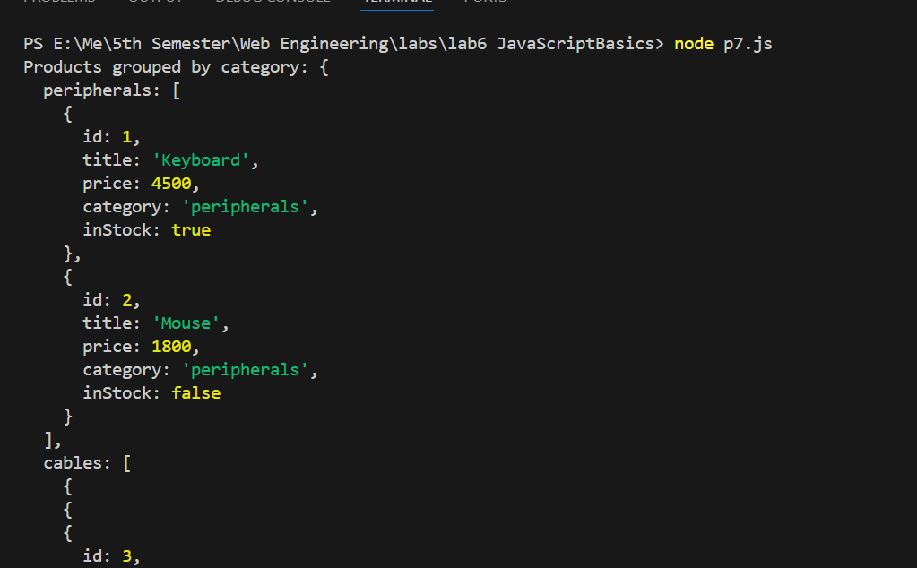
Class Activity: F
- Create calculator.js with calculateBill as above
- Log a happy-path call (2400, 10%, 3 people)
CODE:
function calculateBill({ amount, tipPercent = 15, people = 1 }) {
if (typeof amount !== "number" || amount <= 0) {
throw new Error("Amount must be a positive number");
}
if (people < 1) {
throw new Error("There must be at least one person");
}

const tip = amount * (tipPercent / 100);
const total = amount + tip;

return {
tip: Number(tip.toFixed(2)),
total: Number(total.toFixed(2)),
perPerson: Number((total / people).toFixed(2)),
};
}

console.log(calculateBill({ amount: 2400, tipPercent: 10, people: 3 }));
OUTPUT:
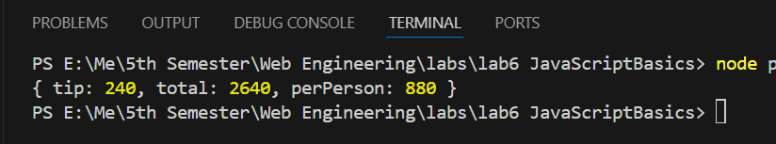

- Wrap two failing calls in try/catch: bad amount, people: 0
- Run node calculator.js — success object + two clear error messages
CODE:

function calculateBill({ amount, tipPercent = 15, people = 1 }) {
if (typeof amount !== "number" || amount <= 0) {
throw new Error("Amount must be a positive number");
}
if (people < 1) {
throw new Error("There must be at least one person");
}

const tip = amount * (tipPercent / 100);
const total = amount + tip;

return {
tip: Number(tip.toFixed(2)),
total: Number(total.toFixed(2)),
perPerson: Number((total / people).toFixed(2)),
};
}

// Happy path
console.log(calculateBill({ amount: 2400, tipPercent: 10, people: 3 }));

// Failing call 1: bad amount
try {
calculateBill({ amount: -1 });
} catch (error) {
console.error(error.message);
}

// Failing call 2: people: 0
try {
calculateBill({ amount: 2400, people: 0 });
} catch (error) {
console.error(error.message);
}

OUTPUT:
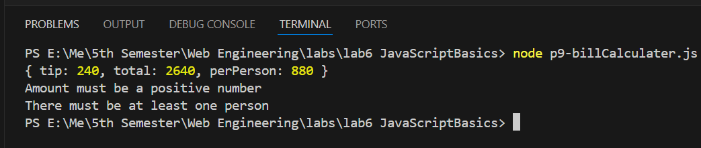
Homework
TASK: 1
Write gradebook.js that, given an array of student objects { name, score }, prints: class average, highest scorer, lowest scorer, pass rate (%), and names sorted high→low. Use only array methods.
CODE:
const students = [
{ name: "Ali", score: 92 },
{ name: "Sara", score: 78 },
{ name: "Bilal", score: 45 }
];

const passingScore = 60;

// 1. Class Average
const totalScore = students.reduce( (sum, s) => sum + s.score, 0)
const classAverage = totalScore / students.length;

// 2. Highest Scorer
const highestScorer = students.reduce( (top, s) => s.score > top.score ? s : top
);

// 3. Lowest Scorer
const lowestScorer = students.reduce( (bottem, s) => s.score < bottem.score ? s : bottem
);

// 4. Pass rate
const passCount = students.filter(s => s.score >= passingScore);
const passRate = (passCount.length / students.length) * 100;

// 5. Names sorted high -> low
const namesSortedHighToLow = students
.slice()
.sort( (a, b) => b.score - a.score)
.map(s => s.name);

console.log("Class Average:", classAverage.toFixed(2));
console.log("Highest Scorer:", highestScorer);
console.log("Lowest Scorer:", lowestScorer);
console.log("Pass Rate:", passRate.toFixed(1) + "%");
console.log("Names sorted high -> low:", namesSortedHighToLow);

OUTPUT:
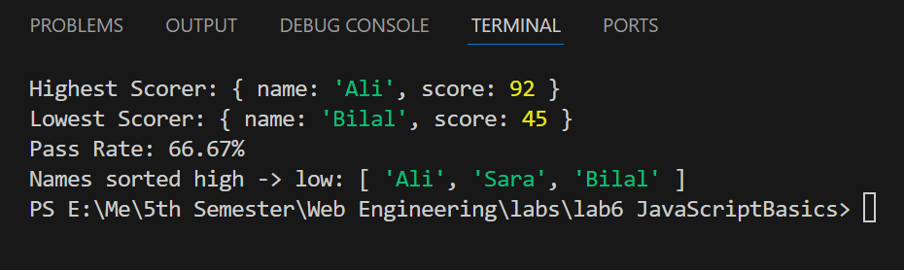

TASK: 2
Write your expected output for each line in a text note, then run and explain any surprises:
console.log([] == false); // true because [] means false
console.log([1, 2, 3] + [4]); // 1,2,3,4 two arrays are added
console.log(typeof null); // null
console.log(0.1 + 0.2 === 0.3); // true because it is === and not ==
console.log([10, 9, 1].sort()); // 1,9,10 because of sort()
console.log(["a", "b"].map(x => x.toUpperCase()).join("-")); //A-B

OUTPUT:
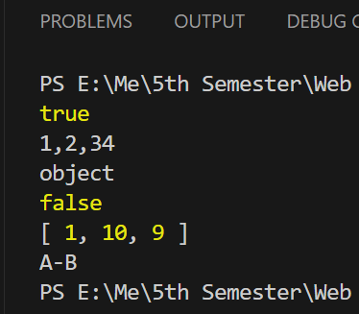

TASK: 3
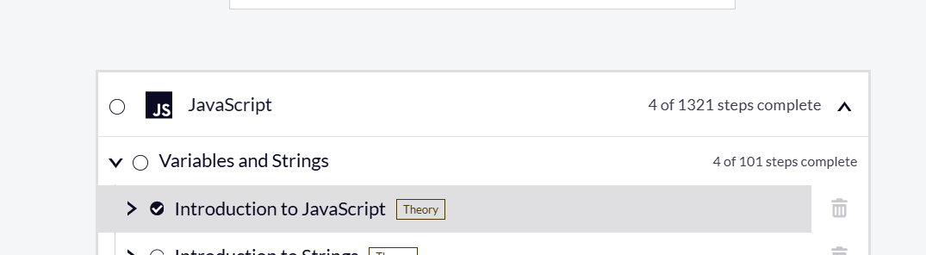

TASK: 4
Complete freeCodeCamp — JavaScript Algorithms and Data Structures, Basic JavaScript section.
CODE:

function calculateBill({ amount, tipPercent = 15, people = 1 }) {
if (typeof amount !== "number" || amount <= 0) {
throw new Error("Amount must be a positive number");
}
if (typeof tipPercent !== "number" || tipPercent < 0) {
throw new Error("Tip percent must be a non-negative number");
}
if (people < 1) {
throw new Error("There must be at least one person");
}

const tip = amount * (tipPercent / 100);
const total = amount + tip;

return {
tip: Number(tip.toFixed(2)),
total: Number(total.toFixed(2)),
perPerson: Number((total / people).toFixed(2)),
};
}

function formatBill(result) {
return `Tip: ${result.tip}
Total: ${result.total}
Per Person: ${result.perPerson}`;
}

// Happy path
const bill1 = calculateBill({ amount: 2400, tipPercent: 10, people: 3 });
console.log(formatBill(bill1));

// Default tip (15%) kicks in
const bill2 = calculateBill({ amount: 1000, people: 2 });
console.log(formatBill(bill2));

// Failing call: bad amount
try {
calculateBill({ amount: -1 });
} catch (error) {
console.error(error.message);
}

// Failing call: people 0
try {
calculateBill({ amount: 2400, people: 0 });
} catch (error) {
console.error(error.message);
}

// Failing call: non-number tipPercent
try {
calculateBill({ amount: 2400, tipPercent: "abc" });
} catch (error) {
console.error(error.message);
}

OUTPUT:


